Copyright reserved

Please turn over

**NATIONAL CERTIFICATE**

**INDUSTRIAL INSTRUMENTS N5**

**AUGUST 2018**

**6**

**This marking guideline consists of 6 pages.**



**MARKING GUIDELINE**

-2-

**SECTION A: FLOW MEASUREMENT**

# QUESTION 1

1.1 1.1.1 H = V22 /2g - V21 /2g where V2 = 0✓

Therefore H = -V21 /2g✓

i.e. the pressure increases by V21 /2g✓

The negative sign indicates that it is an increase in pressure and not a decrease.✓

Increase in head H = V21 /2g or V21 = 2gh✓

V1 =2𝑔𝑔ℎ ✓

Introduce pitot coefficient V

1

=

𝐶𝐶

2

𝑔𝑔

ℎ

✓

(7)

1.1.2

(

6

)

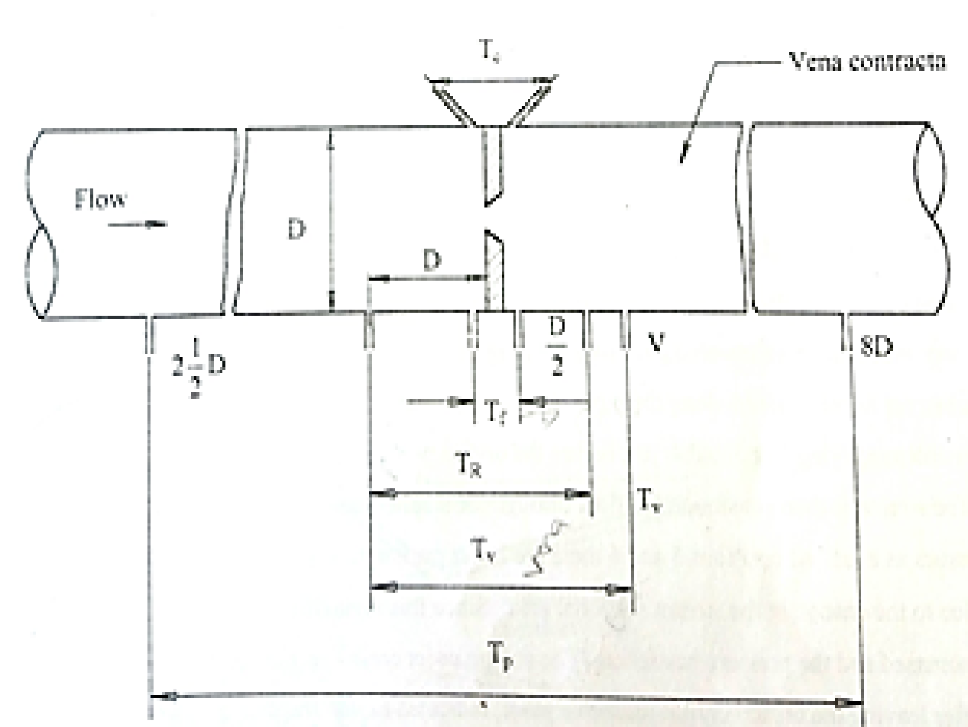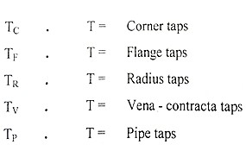

-5-

INDUSTRIAL INSTRUMNETS N5

1.1.3 Advantages

* Pressure loss caused by pitot tube is very small
* Low cost

Disadvantages

* Fluid must be moving at high velocity to produce measurerable differential pressure
* Small opening may be blocked (2 + 2) (4)

1.2 • Laminar flow must be ensured at a point where measurement is taken.

* Obstruction of tube and static connections must be prevented.
* Minimum slope of the tip to the direction of the flow of fluid must be

ensured. (3)

1.3 • Head

* Viscosity
* Frictional resistance (3)

**[23]**

# QUESTION 2

2.1 • It is a vertical tube of conical shape with a gradually expanding area from bottom to top.

* In the tube there is a fluid flowing in an upward direction and a disc is placed in it acting as a float.
* An orifice is set up between the disc and the inside surface of the tube creating a pressure drop.
* A change in flow will affect the pressure drop causing the disc to move up or down until forces acting on the disc are again at equilibrium.
* The position of the float in the tube is a measure of the rate of flow. (5)

* 1. Spiral grooves can be machined into the floats to cause a rotation. This rotation action will discard the sticky fluids from the float by centrifugal force. (3)

* 1. The density of the float must be very large compared to the density of the fluid. This results in reducing the density errors to reasonable proportions. (2)

* 1. • Flow velocity
* Fluid viscosity
* Fluid specific gravity
* Size and the smoothness of the pipe (4)

# [14]

**TOTAL SECTION A: 37**

-4-

**SECTION B: DENSITY, HUMIDITY AND VISCOSITY MEASUREMENT**

# QUESTION 3

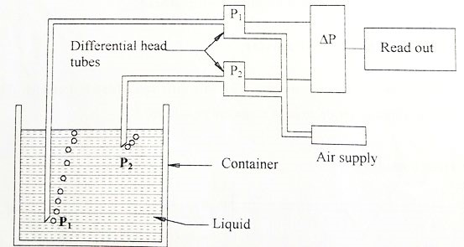3.1

* The differential head type operates with two tubes placed at different levels inside a container in which air is passed through.✓
* A constant air supplied to both the tubes.✓
* The pressure at P1 will be higher than the pressure at P2 thus more pressure is needed at P1 for bubbles to form than at P2.✓
* When the bubbles become visible the pressure put forth at the end of the tube by the liquid will be almost equal to the applied air pressure.✓
* The difference in pressure will be directly proportional to the sum of a constant volume at each tube.✓
* This brings us back to the density equation, thus we can say that ∆P is

directly proportional to the density.✓ (10)

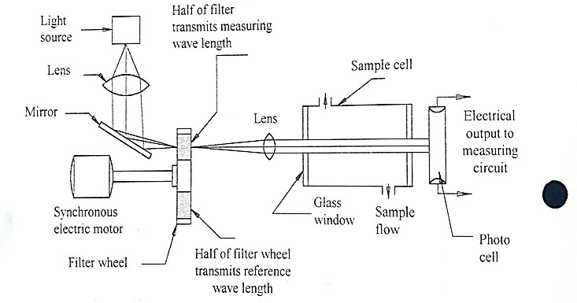3.2

(7)

-2-

3.3 3.3.1 Measure of a fluid’s internal or inter molecular resistance to sheer

force (2)

3.3.2 • Capillary-tube viscometer

* Falling ball/Falling piston viscometer
* Sliding-plate viscometer
* Rotational viscometer
* Vibrating-reed viscometer
* Ultrasonic viscometer
* Float viscometer
* Concentric viscometer (Any 4 × 1) (4)

3.3.3 Poise (1)

**[24]**

**TOTAL SECTION B: 24**

**SECTION C: pH MEASUREMENT**

# QUESTION 4

4.14.1.1True

4.1.2False

4.1.3True

(3 × 1) (3)

4.2• Washing with water and wiping with cotton wool soaked in a diluted

hydrochloric acid will suffice.

* In severe cases the electrodes may require soaking in solvents.
* Inorganic solvents are preferable for greasy and oily deposits.
* Organic solvents have a dehydrating effect on the membrane and therefore only brief immersion in a solvent followed by soaking in hydrochloric acid should be employed.
* A jet of solvent may be used periodically for frequent cleaning.
* An ultrasonic transducer attached to a thin plate may be employed. (6)

4.3• Must have resistance to corrosion

* Strength against thermal shocks
* Strength against mechanical shocks
* Impermeability to water vapour for measurement at high temperatures (4)

4.4To complete the electrical circuit with the glass membrane electrode.✓ It must provide a stable potential that is relatively invariable,✓ despite changes in either the chemical composition of physical properties of the process

stream.✓ (3)

# [16]

**TOTAL SECTION C: 16**

-2-

**SECTION D: AUTOMATIC CONTROL**

# QUESTION 5

5.15.1.1A

5.1.2E5.1.3E5.1.4E

5.1.5D

5.1.6B

5.1.7D

(7 × 2) (14)

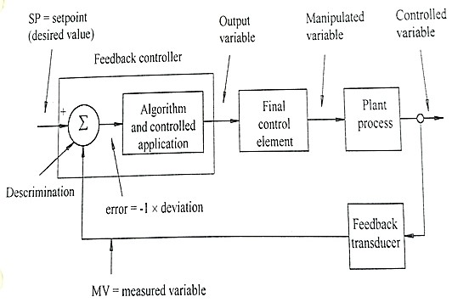5.2

(9)

# [23]

**TOTAL SECTION D:**   **23**

**GRAND TOTAL :** **100**